LECTURE 4
API AND OS STRUCTURE

1. Process API
What it means
A Process API is a set of system functions that allow programs to create, control, and manage processes in an operating system.
Why it is needed
Programs cannot directly manage processes themselves. Instead, they use special OS functions (system calls) to ask the operating system to do it.
Main tasks handled by Process API
- Creating new processes
- Running programs
- Ending processes
- Allowing parent processes to wait for child processes
Key system calls used
- fork() → creates a new process
- exec() → runs a new program in a process
- exit() → terminates a process
- wait() → parent waits for a child to finish
These functions form the core process management interface in Linux/Unix systems.

2. What is an API?
Definition
An API (Application Programming Interface) is a set of functions that allow software programs to communicate with another system or component.
In operating systems, the API allows applications to communicate with the OS.
System Calls
Operating systems provide special functions called system calls.
System calls:
- Are part of the operating system code
- Run with higher privileges (kernel mode)
- Can perform operations that normal programs cannot
Examples of tasks system calls can perform:
- Access hardware
- Create processes
- Manage memory
- Read/write files
Important Idea
System calls are different for different operating systems.
Example:
- Linux system calls
- Windows system calls
To make them easier to use, programming languages provide libraries that wrap system calls.
Example in C:
printf()
Internally it may use the write() system call to display output.

3. POSIX
Definition
POSIX (Portable Operating System Interface) is a standard set of APIs for operating systems.
It was created to make software portable across different operating systems.
Why POSIX is important
Different operating systems may have different system calls.
POSIX solves this problem by defining a standard interface.
If a program follows POSIX:
- It can run on any POSIX-compliant operating system.
Examples of POSIX systems
- Linux
- macOS
- UNIX
- BSD systems
Role of Libraries
Libraries provide an easy way to access POSIX APIs.
Example:
- The C library (libc) contains functions that internally use system calls.
Example:
printf()
internally may call
write()
So programmers use simple functions, while the library interacts with the OS.

4. Linux System Calls
The Linux kernel provides many system calls for interacting with the operating system.
Some of these system calls are specifically used for process management.
Important Linux Process System Calls
1. fork()
- Creates a new process
- The new process is called a child process
- The process that creates it is the parent process
Every process in Linux is created using fork().
The first process in Linux is called:
init
2. exec()
- Used to run a program inside a process
- It replaces the current program with another program
Example idea:
A process is created with fork(), then it loads a program using exec().
3. exit()
- Used when a process finishes execution
- It terminates the process and returns control to the OS
4. wait()
- Used by a parent process
- It makes the parent wait until the child process finishes
This is useful to control process execution order.

5. Process Creation
What is Process Creation?
Process creation means starting a new process (program in execution) in the operating system.
In Linux/Unix systems, a new process is created using the fork() system call.
How fork() works
When a program calls fork(), the OS creates a copy of the current process.
So after fork() there are two processes:
- Parent process → the original process
- Child process → the new process created
Important behavior of fork()
- The child process is almost an exact copy of the parent.
- Both processes continue execution from the same line after fork().
- Each process has its own memory space.
Return values of fork()
Process | fork() return value
Child process | 0
Parent process | Child’s PID
PID = Process ID
Important point
We cannot guarantee which process runs first (parent or child).
The operating system scheduler decides that.

6. Process Termination
What is Process Termination?
Process termination means ending a process when its work is finished.
A process can terminate in two ways:
1. Voluntary termination
The process ends itself by calling:
exit()
This tells the operating system that the program has finished.
2. OS termination
Sometimes the operating system may terminate a process due to:
- errors
- illegal operations
- system policies
The wait() system call
A parent process can wait for its child process to finish using:
wait()
This can be:
- Blocking → parent stops until child finishes
- Non-blocking → parent checks but continues running
Special Process States
Zombie Process
A zombie process occurs when:
- Child process has finished execution
- Parent has not yet collected its exit status
So the process still exists in the process table.
Orphan Process
An orphan process happens when:
- The parent process terminates first
- Child process is still running
In this case:
The init process becomes the new parent.

7. Running Another Process
Problem
fork() creates a copy of the same program.
But sometimes we want the child to run a completely different program.
Solution → exec()
The exec() system call replaces the current program with a new program.
Important behavior:
- It overwrites the current process memory
- The process starts running the new program
Important point
exec() does not create a new process.
It changes the program running in the current process.
Fork + Exec Pattern
In most programs:
- fork() → create child process
- exec() → child runs another program
This is a very common pattern in UNIX systems.

8. The Shell
What is a Shell?
A shell is a program that allows users to interact with the operating system using commands.
Examples:
- bash
- zsh
- sh
When you type commands in the terminal, the shell runs them for you.
How the Shell Runs a Command
When you enter a command like:
ls
The shell performs these steps:
- fork()
  - Create a child process
- exec()
  - Child loads and runs the command program
- wait()
  - Parent shell waits for the command to finish
- After completion
  - Shell displays the command prompt again
Environment Inheritance
By default, the child process inherits the parent’s environment, such as:
- environment variables
- file descriptors
- working directory
This allows commands to run in the same environment.

9. Pipes
What are Pipes?
Pipes allow communication between processes.
They connect the output of one process to the input of another process.
In the shell, pipes use the symbol:
|
Example:
ls | grep txt
Meaning:
- ls produces output
- Output goes into a pipe (kernel buffer)
- grep reads from the pipe as input
How Pipes Work Internally
When the shell sees a pipe:
- It creates two processes
- The OS creates a kernel pipe (queue)
- Connections are made:
Process | Action
Process 1 | Writes output to pipe
Process 2 | Reads input from pipe
So data flows like this:
Process 1 → Kernel Pipe → Process 2
This allows programs to work together efficiently.

Operating System Services

What are Operating System Services?
An Operating System (OS) provides different services to make it easier for users and programs to use the computer system.
These services create an environment where programs can run efficiently and safely.
The services can be divided into two main groups:
- Services helpful to users and programs
- Services that help the system operate efficiently

1. Services Helpful to Users and Programs
These services make it easier for users and applications to interact with the computer.
1. User Interface (UI)
The User Interface allows the user to interact with the operating system.
Most operating systems provide one or more types of interfaces.
Types of User Interfaces
1. Command Line Interface (CLI)
- Users type commands using the keyboard.
- The system executes commands entered by the user.
Example:
ls
cd documents
mkdir folder
Common in Linux and Unix systems.
2. Graphical User Interface (GUI)
- Uses windows, icons, menus, and pointers.
- Users interact using mouse, keyboard, or touch.
Examples:
- Microsoft Windows
- macOS
- Linux GUI environments
3. Batch Interface
- Commands are written in a file and executed automatically.
- No direct user interaction during execution.
2. Program Execution
The operating system must allow programs to run properly.
Steps performed by the OS:
- Load the program into main memory
- Execute the program instructions
- Manage program execution
- End the program when finished
A program may terminate:
- Normally (successful completion)
- Abnormally (error or crash)
3. I/O Operations
Programs often need to interact with input/output devices such as:
- Keyboard
- Mouse
- Hard disk
- Printer
- Network devices
The operating system provides functions to read from or write to these devices.
Example:
- Reading a file from disk
- Printing a document
Users and programs do not interact directly with hardware.
Instead, the OS controls all I/O operations.
4. File-System Manipulation
The operating system manages the file system, which stores data on storage devices.
Programs need services to perform file operations.
Common file operations
- Create files
- Delete files
- Read files
- Write files
- Create directories
- Search files
- List file information
- Manage file permissions
Example operations:
create file
open file
read data
write data
delete file
The OS ensures files are stored, organized, and accessed safely.
5. Communication
Sometimes processes need to communicate with each other.
This communication may happen:
- Within the same computer
- Between computers over a network
Two common communication methods
1. Shared Memory
- Two processes access the same memory area.
- They exchange data through this shared space.
2. Message Passing
- Processes send and receive messages through the operating system.
- Often used in distributed systems.
Example:
- A client sending a request to a server.
6. Error Detection
Errors may occur during program execution or system operation.
Errors can happen in:
- CPU
- Memory
- Input/output devices
- User programs
The operating system constantly monitors the system to detect errors.
When an error occurs, the OS:
- Reports the error
- Takes corrective action
- Prevents system crashes
Example:
- File not found
- Invalid memory access
- Hardware failure
Debugging tools can help programmers identify and fix errors.

2. Services for Efficient System Operation
These services ensure the system runs efficiently and securely, especially when multiple users or programs are running.
1. Resource Allocation
The computer has limited resources such as:
- CPU time
- Main memory
- Disk space
- I/O devices
When multiple programs run at the same time, the operating system must allocate resources fairly.
Example:
- CPU scheduling between programs
- Memory allocation to processes
- Managing printer access
The OS decides which program gets which resource and for how long.
2. Accounting
Accounting keeps track of how system resources are used.
The OS records information such as:
- CPU time used by a program
- Memory usage
- Disk usage
- Network usage
This information can be used for:
- Performance analysis
- System improvement
- Billing users in shared systems
Example:
- Tracking usage in cloud computing systems.
3. Protection and Security
Protection and security ensure that system resources are accessed safely and correctly.
Protection
Protection ensures that processes do not interfere with each other.
Example:
- One program cannot access another program's memory.
Security
Security protects the system from unauthorized access or attacks.
Security measures include:
- User authentication (login with password)
- Access control
- Data protection
- Network security
Example:
- Only authorized users can access certain files.

3. A View of Operating System Services
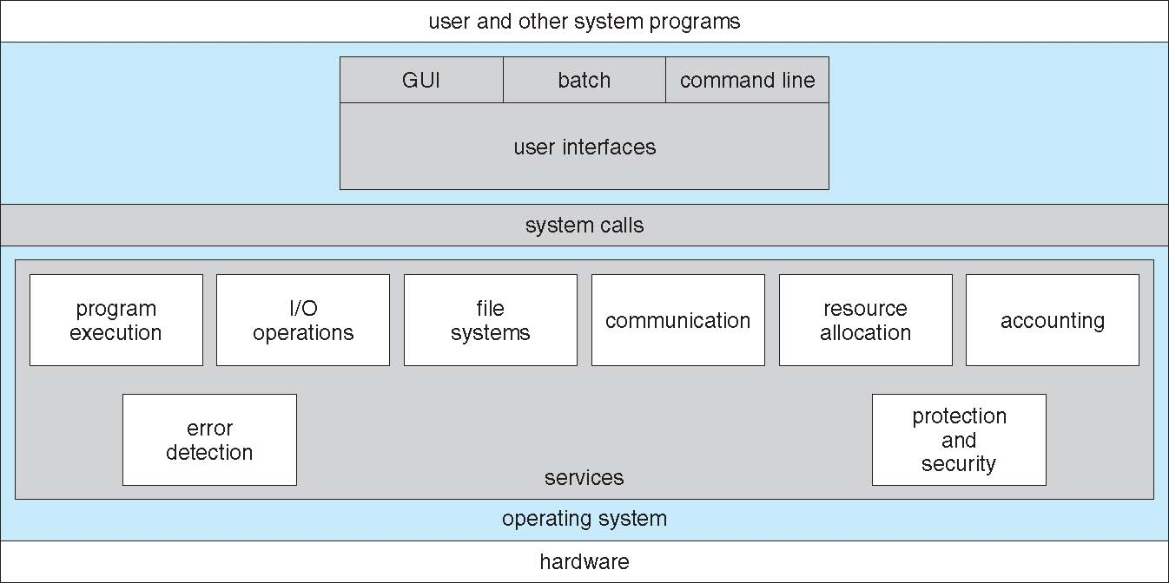

4. User Operating System Interface
What is a User Operating System Interface?
The User Operating System Interface is the method through which a user interacts with the operating system.
It allows users to:
- Run programs
- Manage files
- Control system operations
- Communicate with the computer
In simple words, it is the bridge between the user and the operating system.
Operating systems may provide different types of interfaces depending on the device and user needs.
The most common types are:
- Command Line Interface (CLI)
- Graphical User Interface (GUI)
- Touchscreen Interface
User Operating System Interface – CLI
What is CLI?
CLI (Command Line Interface) is an interface where users type commands using the keyboard to interact with the operating system.
It is also called a command interpreter.
The command interpreter:
- Reads the command entered by the user
- Interprets the command
- Executes the requested action
Characteristics of CLI
- Interaction happens through text commands
- Requires users to remember commands
- Very powerful and flexible
- Used mostly by system administrators and programmers
Example Commands
Examples in Linux/Unix:
ls
cd documents
mkdir newfolder
rm file.txt
Each command tells the operating system to perform a specific task.
Where CLI is Implemented
The command interpreter may be:
- Part of the operating system kernel
- A system program outside the kernel
Many operating systems allow multiple command interpreters (shells).
Examples:
- Bash
- Zsh
- Sh
Built-in vs External Commands
Commands can be:
Built-in commands
- Directly part of the command interpreter
Example:
cd
External commands
- Separate programs executed by the shell
Example:
ls
User Operating System Interface – GUI
What is GUI?
A GUI (Graphical User Interface) allows users to interact with the operating system using graphics instead of text commands.
Users interact through:
- Windows
- Icons
- Menus
- Pointer (mouse)
This model is often called the desktop metaphor because the screen looks like a physical desktop.
Main Components of GUI
Icons
- Represent files, programs, or folders.
Windows
- Rectangular areas where programs run.
Menus
- Provide a list of available options.
Pointer
- Controlled by mouse or touchpad to select items.
How GUI Works
Users perform actions such as:
- Clicking icons
- Dragging files
- Opening folders
- Running programs
These actions send commands to the operating system.
Advantages of GUI
- Easy to learn
- User-friendly
- Visual interaction
- No need to memorize commands
Examples of GUI Systems
- Microsoft Windows
- macOS
- Linux desktop environments (GNOME, KDE)
Many operating systems provide both GUI and CLI interfaces.
Touchscreen Interfaces
What are Touchscreen Interfaces?
Touchscreen interfaces allow users to interact directly with the screen using their fingers.
Instead of using a mouse or keyboard, users perform actions through touch gestures.
Why Touchscreen Interfaces are Needed
On devices like:
- Smartphones
- Tablets
- Interactive kiosks
Using a mouse is not practical, so touchscreen interfaces are used.
Common Touch Gestures
Examples include:
Tap
- Select an item
Swipe
- Move between screens
Pinch
- Zoom in or out
Long press
- Open additional options
Examples of Touchscreen Systems
- Android
- iOS
- Windows touchscreen devices
The Mac OS X GUI
Overview
The Mac OS X GUI is the graphical interface used in Apple's macOS operating system.
It is known as the Aqua Interface.
This interface is designed to be simple, attractive, and user-friendly.
Key Features of Mac OS X GUI
1. Desktop Environment
The main workspace where users can:
- Access files
- Open programs
- Manage windows
2. Dock
A bar that contains:
- Frequently used applications
- Running programs
- Quick shortcuts
3. Finder
Finder is the file manager in macOS.
It allows users to:
- Browse files
- Organize folders
- Search files
4. Menu Bar
Located at the top of the screen.
It provides options for:
- Application controls
- System settings
- File operations
Important Technical Detail
Although macOS has a graphical interface, internally it is based on a UNIX operating system.
This means macOS also supports:
- CLI commands
- UNIX shell environments
Example terminal command:
ls
cd Documents
So macOS combines:
- GUI for normal users
- CLI for advanced users

5. System Calls
What are System Calls?
A system call is the way a program requests a service from the operating system.
User programs cannot directly access hardware or kernel resources, so they must ask the OS to perform tasks for them.
This request is done using system calls.
In simple words:
System calls are the interface between user programs and the operating system.
Why System Calls Are Needed
Programs often need to perform tasks such as:
- Creating processes
- Reading or writing files
- Communicating with devices
- Allocating memory
Since these operations involve hardware or protected resources, the OS must control them.
System calls allow programs to safely request these services from the OS.
How Programs Access System Calls
System calls are usually not used directly by programmers.
Instead, programs use APIs (Application Programming Interfaces).
An API provides easy-to-use functions that internally call system calls.
Common APIs
There are three widely used APIs:
API | Used By
Win32 API | Microsoft Windows
POSIX API | UNIX, Linux, macOS
Java API | Java Virtual Machine (JVM)
Programs use these APIs instead of directly calling system calls.
Example of a System Call
Consider a program that copies data from one file to another.
To perform this operation, several system calls may be used:
- Open the source file
- Create the destination file
- Read data from source
- Write data to destination
- Close both files
So even a simple operation like copying a file requires multiple system calls.
Programming Languages and System Calls
System calls are usually accessed through high-level programming languages, such as:
- C
- C++
These languages use libraries that provide functions for system calls.
Example in C:
printf("Hello");
Here:
- printf() is a library function
- It internally calls the write() system call
- The OS then sends output to the screen
So the flow is:
Program → Library Function → System Call → Operating System

6. System Call Implementation
What is System Call Implementation?
System call implementation describes how the operating system handles a system call request internally.
When a program requests a service, the OS must determine which system call to execute and how to perform it.
System Call Numbers
Each system call is assigned a unique number.
Example concept:
System Call | System Call Number
read() | 3
write() | 4
open() | 5
The program sends the system call number to the OS.
This number tells the operating system which function to execute.
System Call Interface
The system call interface is the part of the OS that receives system call requests.
Its job is to:
- Identify the system call requested
- Execute the correct kernel function
- Return results to the program
How It Works Step-by-Step
- A program calls an API function.
- The API places the system call number in a register or memory location.
- The program triggers a system call instruction.
- Control switches from user mode to kernel mode.
- The system call interface checks the number.
- The OS executes the corresponding kernel function.
- The result is returned to the program.
System Call Table
Operating systems maintain a system call table.
This table stores addresses of all system call functions.
Example idea:
System Call Number | Function
1 | process_create
2 | process_exit
3 | read
4 | write
The OS simply looks up the table and runs the correct function.
This makes system calls efficient and fast.
Hidden Complexity for Programmers
Programmers do not need to know how system calls are implemented internally.
They only need to:
- Use the correct API
- Understand what the system call does
Most internal details are hidden by libraries and runtime support.
Role of Runtime Support Libraries
A runtime support library contains functions that help programs interact with the operating system.
These libraries:
- Provide APIs
- Manage system calls
- Handle communication with the kernel
Examples:
- Standard C Library (libc)
- Windows system libraries
Relationship Between API, System Calls, and OS
The interaction works like this:
User Program
↓
API (library functions)
↓
System Calls
↓
Operating System Kernel
↓
Hardware
So the OS is protected from direct user access, while programs can still use its services.

7. Types of System Calls
System calls can be grouped into different categories based on the type of service they provide to programs.
The main types are:
- Process Control
- File Management
- Device Management
- Information Maintenance
- Communication
- Protection
Each type performs a specific role in the operating system.
1. Process Control
Process control system calls are used to manage processes (programs that are running).
A process goes through different stages such as creation, execution, and termination, and these system calls control those stages.
Common operations
Create Process
- Starts a new process.
Example concept:
fork()
Terminate Process
- Ends a running process.
Example:
exit()
Load and Execute Program
- Loads a program into memory and starts running it.
Example:
exec()
Get or Set Process Attributes
- Retrieve or modify information about a process.
Examples:
- Process ID
- Process priority
- Memory usage
Wait for Event
- A process may pause execution until a specific event occurs.
Example:
- Waiting for another process to finish.
Signal Event
- Used to notify another process that an event has occurred.
Allocate and Free Memory
- Assign memory to processes or release unused memory.
Debugging Operations
- Used by debugging tools to analyze programs.
Example:
- Single-step execution (running one instruction at a time).
Locks for Shared Data
- Prevent multiple processes from modifying shared data at the same time.
2. File Management
File management system calls allow programs to work with files stored in the system.
Files store important information such as:
- Documents
- Programs
- Databases
Common file operations
Create File
- Create a new file in storage.
Delete File
- Remove a file from the system.
Open File
- Prepare a file for reading or writing.
Close File
- Close the file after operations are complete.
Read File
- Retrieve data from a file.
Write File
- Store data in a file.
Reposition File
- Move the file pointer to another position.
Example:
- Jumping to the middle of a file.
Get File Attributes
- Retrieve file information such as:
  - size
  - permissions
  - creation date
Set File Attributes
- Modify file properties.
Example:
- Changing file permissions.
3. Device Management
Device management system calls control hardware devices connected to the computer.
Examples of devices:
- Printers
- Hard drives
- Keyboards
- Monitors
- Network cards
Common device operations
Request Device
- Ask permission to use a device.
Release Device
- Release the device after use.
Read Device
- Read data from the device.
Example:
- Reading from keyboard.
Write Device
- Send data to the device.
Example:
- Printing a document.
Get Device Attributes
- Retrieve information about the device.
Set Device Attributes
- Change device settings.
Attach / Detach Devices
- Connect or disconnect devices logically.
Example:
- Mounting or unmounting a disk.
4. Information Maintenance
These system calls are used to retrieve or update system information.
Common operations
Get Time or Date
- Retrieve current system time or date.
Set Time or Date
- Change system clock settings.
Get System Data
- Retrieve system information such as:
  - CPU usage
  - memory usage
  - system statistics
Set System Data
- Modify system settings.
Get Process/File/Device Attributes
- Retrieve information about system resources.
Set Process/File/Device Attributes
- Change attributes of system resources.
5. Communication
Communication system calls allow processes to exchange information.
Processes may communicate:
- On the same computer
- Across different computers in a network
Common communication operations
Create Communication Connection
- Establish a communication link between processes.
Delete Communication Connection
- Close the communication link.
Send Messages
- Send information from one process to another.
Receive Messages
- Receive messages from other processes.
Two main communication models
Message Passing
- Processes send messages through the OS.
Example:
Process A → OS → Process B
Shared Memory
- Processes share a common memory space to exchange data.
Transfer Status Information
- Send status updates between processes.
Attach / Detach Remote Devices
- Connect or disconnect network resources.
6. Protection
Protection system calls ensure system security and controlled access to resources.
They prevent unauthorized users or programs from accessing protected data.
Common protection operations
Control Access to Resources
- Restrict access to files, memory, or devices.
Get Permissions
- Check user access rights.
Example:
- Read permission
- Write permission
- Execute permission
Set Permissions
- Change access rights for users.
Allow or Deny User Access
- Grant or restrict user access to resources.
Example:
- File access control.

8. API – System Call – OS Relationship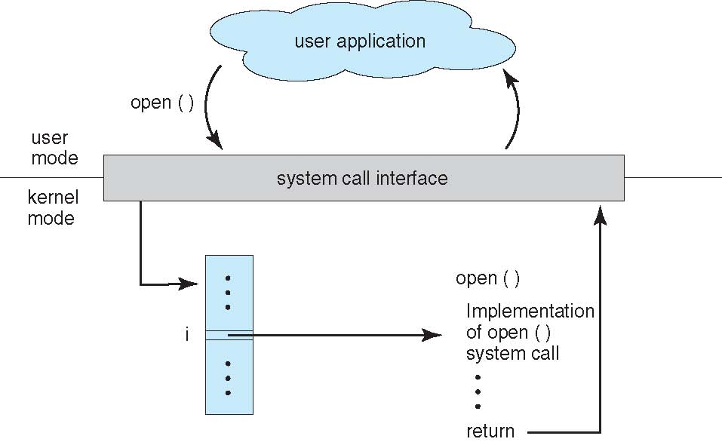
This diagram explains the relationship between an API, system calls, and the operating system and shows how a user program communicates with the OS to perform operations such as opening a file.
The process begins with a user application running in user mode. User programs cannot directly access hardware or kernel resources for security reasons. When the application needs a service from the operating system, such as opening a file, it calls a function provided by an API (Application Programming Interface), for example open(). This API function acts as a convenient interface for programmers and internally prepares a request for the operating system.
After the API function is called, the request is passed to the system call interface, which forms the boundary between user mode and kernel mode. The system call interface receives the request and identifies which system call the program is requesting. Each system call is associated with a unique number or index (shown as “i” in the diagram). Using this number, the system call interface looks up the correct entry in the system call table.
Once the correct system call is identified, control is transferred to the kernel mode, where the operating system executes the implementation of the requested system call, such as the internal function that performs the open() operation. At this stage, the OS interacts with the file system or hardware if necessary to complete the request.
After the operating system finishes executing the system call, the result (such as success or an error code) is returned back through the system call interface. The system then switches from kernel mode back to user mode, and the result is delivered to the user application that originally requested the service.
In summary, the flow shown in the diagram is: User Application → API function call → System Call Interface → System Call Table lookup → OS Kernel executes the system call → Result returned to the application. This layered approach ensures security, controlled access to system resources, and easier programming through APIs.

9. Examples of Windows and Unix System Calls
